Catalog Number: 193999  
**p-Nitro blue tetrazolium, molecular biology reaction**  
  
  
**Structure:**  
  
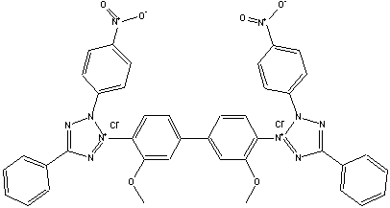  
  
**Molecular Formula:** C40H30N10O6 **.** 2CI  
  
**Molecular Weight:** 817.6  
  
**CAS #** 298-83-9  
  
**Synonyms:** NBT; Nitro BT; 3, 3'-(3,3'-dimethoxy 1,1'-biphenyl)-4,4-diyl) bis(4-nitrophenyl)-5-(phenyl-dichloride)2H-(tetrazolium)  
  
**Physical Appearance:** Yellow crystalline powder  
  
**Description:** Ideal for alaline phosphatase conjugate detection in nucleic acid probe detection systems  
  
**Available in sizes:**  
  
50 mg  
250 mg  
1 gm  
  
**Solubility:** Very slightly soluble in water